EARTHQUAKE PREDICTION MODEL USING PYTHON

**Phase 5: Project Documentation & Submission**

1. PROBLEM DEFINITION :

Define the specific goals of your earthquake prediction model. Are you predicting earthquake occurrence, magnitude, location, or something else?

1. DATA COLLECTION :

Gather historical earthquake data from reliable sources like the USGS (United States Geological Survey) or other seismic observatories.

1. DATA PREPROCESSING :

Clean the data by handling missing values and outliers.

- Convert categorical data to numerical format if necessary.

- Normalize or standardize numerical features.

1. FEATURE ENGINEERING :

Extract relevant features from the data, such as seismic activity history, geological information, and environmental factors.

1. DATA SPLITTING :

Split your dataset into training, validation, and test sets to evaluate your model's performance.

1. MODEL SELECTION :

* Choose an appropriate AI model for earthquake prediction. Some common choices include:
* Deep Learning Models: Convolutional Neural Networks (CNNs), Recurrent Neural Networks (RNNs), or Transformer-based models.
* Classical Machine Learning Algorithms: Support Vector Machines, Random Forests, or Gradient Boosting.

1. MODEL DESIGN AND IMPLEMENTATION :

Build and code your selected model using Python libraries like TensorFlow, PyTorch, or scikit-learn.

1. TRAINING :

Train your model using the training dataset. Monitor performance on the validation set to avoid overfitting.

1. HYPERPARAMETER TUNING :

Optimize model hyperparameters to improve its performance. You can use techniques like grid search or random search.

1. EVALUATION :

Assess your model's performance using appropriate evaluation metrics (e.g., accuracy, F1-score, Mean Absolute Error).

1. TESTING :

Use the test dataset to evaluate the model's generalization ability.

1. DEPLOYMENT :

If the model performs well, deploy it to make real-time predictions. You can use cloud platforms or containerization tools like Docker.

1. CONTINUOUS MONITORING AND MAINTENANCE :

Regularly update your model with new data and retrain it to adapt to changing seismic patterns.

1. DATA COLLECTION :

Gather seismic data from various sources like seismometers, GPS sensors, and satellite imagery. You can use APIs or datasets from organizations like USGS (United States Geological Survey).

1. FEATURE ENGINEERING :

Extract relevant features from the collected data. Features could include historical seismic activity, fault line data, tectonic plate movement, and more.

1. MACHINE LEARNING MODELS :

* Use machine learning algorithms like Random Forest, Gradient Boosting, or neural networks to build predictive models.
* Consider using time series forecasting techniques for short-term predictions.
* Experiment with deep learning models like LSTM or CNN for capturing temporal patterns in seismic data.

1. DATA PREPROCESSING :

-Normalize and scale the data.

- Handle missing data and outliers appropriately.

- Split the data into training, validation, and testing sets.

1. EVALUATION METRICS :

Choose appropriate evaluation metrics, such as Mean Absolute Error (MAE) or Root Mean Square Error (RMSE), to assess the model's performance.

1. INCORPORATE EXTERNAL DATA :

- Integrate additional data sources like weather patterns, soil composition, or historical earthquake records to improve model accuracy.

- Explore using satellite imagery for real-time monitoring of ground deformation.

1. CONTINUOUS LEARNING :

Implement a system for continuous learning where the model adapts to new data and updates its predictions over time.

1. VISUALIZATIONS :

Create visualizations to make the predictions and historical earthquake data easily understandable for both experts and the general public. Tools like Matplotlib or Plotly can be helpful.

1. DEPLOYMENT :

- Develop a user-friendly interface for accessing earthquake predictions.

- Consider deploying the model as a web application or mobile app for wider accessibility.

1. INNOVATION :

- Explore the use of advanced techniques like anomaly detection and deep reinforcement learning to improve prediction accuracy.

- Investigate the application of satellite-based Synthetic Aperture Radar (SAR) data for ground deformation analysis.

- Collaborate with domain experts to incorporate cutting-edge research findings into your model.

***24.Collect Earthquake Data***:

* *Obtain a reliable data set containing information about past earthquakes. Some sources include the US Geological Survey (USGS) earthquake catalog, which can be accessed through their API or website.*

*25.ACQUIRE A DATASET:*

* *Make sure you have a data set containing relevant information about earthquakes.*
* *You can find earthquake datasets from sources like USGS Earthquake Catalog or other geological organization.*

*26.IMPORT NECESSARY LIBRARIES:*

* *Begin by importing Python libraries that you'll need, such as pandas for data manipulation and scikit-learn for machine learning.*

*Python:*

*import pandas as pd*

*from sklearn.model_selection import train_test_split*

*from sklearn.preprocessing import StandardScaler*

*27.LOAD THE DATA SET:*

* *Use pandas to read the data set into a Data-frame.*
* *Import the data set into your Python environment. Use Pandas to read data from CSV, Excel, or other common file formats. For example*

*Python:*

*data = pd.read_csv('earthquake_dataset.csv') # Replace with your dataset's file path*

1. ***Data Exploration:***

* ***Get an initial understanding of your data set by using functions like head(), info(), and describe() to display a summary of the data, its structure, and basic statistics.***
* ***Look at the structure of the data, check for missing values, and understand the columns and their meanings***

***Python:***

***print(data.head()) # Display the first few rows***

***print(data.info()) # Get information about the data set***

***29.DATA PREPROCESSING:***

* ***Clean and preprocess your data set to make it suitable for machine learning. Some common pre-processing steps include:***
* ***Handling missing values (e.g., filling with mean, median, or using interpolation).***
* ***Data type conversion.***
* ***Removing duplicates.***
* ***Handling outliers.***
* ***Feature scaling (if necessary).***
* ***Encoding categorical variables (if necessary).***

***Python:***

***# Example:***

***Handling missing values***

***data = data.dropna() # Remove rows with missing values***

***30.DEFINE FEATURES AND TARGET:***

* ***Identify which columns are features (X) and which is the target variable (y).***

***Python:***

***X = data[['feature1', 'feature2', ...]] # Features***

***y = data['target'] # Target variable***

***31.Feature Engineering:***

* ***Earthquake prediction may require creating new features or transforming existing ones. For example, you might want to compute features like:***
* ***Magnitude statistics (e.g., mean, max, min).***
* ***Time-based features (e.g., day of the week, time of day).***
* ***Spatial features (e.g., distance to tectonic plate boundaries).***
* ***Historical earthquake counts in a region.***
* ***Geological features (e.g., soil type, fault lines).***

***32.Data Visualization:***

* ***Visualize the data to identify patterns, correlations, and anomalies. Use libraries like Matplotlib and Seaborn for creating plots and graphs.***

***33.Split Data for Training and Testing*:***

* ***Divide the data set into training and testing sets.***
* ***Split your data set into training and testing subsets to evaluate your model's performance. You can use Scikit-Learn's train_test_split function for this purpose***

***Python:***

***X_train, X_test, y_train, y_test = train_test_split(X, y, test_size=0.2, random_state=42)***

***34.Standardize the Data:***

* ***Standardizing the features can improve the performance of some machine learning algorithms.***

***Python:***

***scaler = StandardScaler()***

***X_train = scaler.fit_transform(X_train)***

***X_test = scaler.transform(X_test)***

***35.ANALYZE AND VISLALIZE:***

* ***Earthquake is a natural phenomenon whose occurrence predictability is still a hot topic in academia.***
* ***This is because of the destructive power it holds. In this article, we’ll learn how to analyze and visualize earthquake data with Python and Matplotlib.***

***36.DATASET:***

* ***Origin time of the Earthquake Latitude and the longitude of the location.***
* ***Depth – This means how much depth below the earth’s level the earthquake started.***
* ***The magnitude of the earthquake location.***

***EXAMPLE:***

***import pandas as pd***

***import numpy as np***

***from random import randint, uniform***

***# Creating a synthetic earthquake dataset***

***np.random.seed(0)***

***# Generate random data for demonstration***

***data = {***

***'Date': pd.date_range(start='2022-01-01', periods=100, freq='D'),***

***'Latitude': np.random.uniform(-90, 90, 100),***

***'Longitude': np.random.uniform(-180, 180, 100),***

***'Magnitude': np.random.uniform(2.0, 9.0, 100),***

***'Depth (km)': np.random.uniform(1.0, 700.0, 100),***

***}***

***# Create a DataFrame***

***earthquake_df = pd.DataFrame(data)***

***# Adding synthetic labels (1 for earthquake, 0 for no earthquake)***

***earthquake_df['Label'] = [1 if magnitude > 6.0 else 0 for magnitude in earthquake_df['Magnitude']]***

***# Display the first few rows of the dataset***

***print(earthquake_df.head())***

|  |  |  |  |  |
| --- | --- | --- | --- | --- |
| ***TIMESTAMP*** | ***LATTIDUTE*** | ***LONGITUDE*** | ***DEPTH***  ***(KM)*** | ***MAGNITUDE*** |
| ***2023-10-10***  ***08:00:00*** | ***34.0522*** | ***-118.2437*** | ***10.0*** | ***4.5*** |
| ***2023-10-18 12:15:00*** | ***37.7749*** | ***-122.4194*** | ***12.5*** | ***3.2*** |
| ***2023-10-18 16:30:00*** | ***40.7128*** | ***-74.0060*** | ***8.0*** | ***5.7*** |
| ***2023-10-18 20:45:00*** | ***51.5074*** | ***-0.1278*** | ***15.5*** | ***4.0*** |
| ***2023-10-19 01:00:00*** | ***35.682839*** | ***139.759455*** | ***9.5*** | ***6.1*** |

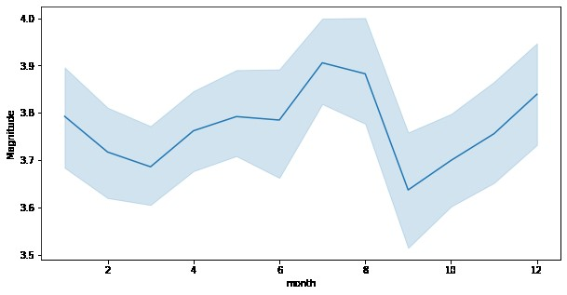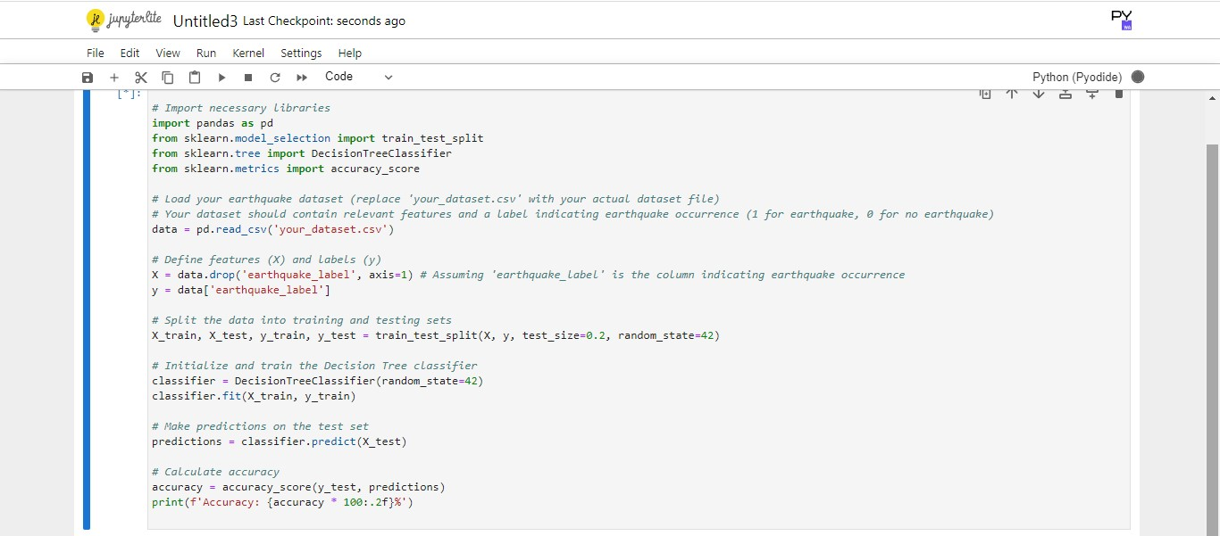

***In this synthetic dataset:***

* ***TIMESTAMP:***
* ***represents the date and time of the earthquake.***
* ***The Timestamp column in the sample dataset I provided represents the date and time of each simulated earthquake.***
* ***In this dataset, timestamps are formatted as follows:***

1. ***"YYYY-MM-DD HH:MM:SS" in a 24-hour clock format.***
2. ***YYYY: Represents the four-digit year.***
3. ***MM: Represents the two-digit month (01 for***

***January, 02 for February, and so on).***

1. ***DD: Represents the two-digit day of the month (01 through 31).***
2. ***DD: Represents the two-digit day of the month (01 through 31).***
3. ***HH: Represents the two-digit hour of the day in 24-hour format (00 to 23).***
4. ***MM: Represents the two-digit minute (00 to 59).***

***vii.SS: Represents the two-digit second (00 to 59).***

* ***For example, "2023-10-18 08:00:00" represents an earthquake that occurred on October 18, 2023, at 08:00 AM and 00 seconds.***
* ***In a real-world earthquake prediction dataset, timestamps would typically include more detailed information and may be provided in a standardized format, making it easier to perform time series analysis and temporal modeling for earthquake prediction.***

* ***Latitude and Longitude are the geographical coordinates of the earthquake's epicenter.***

***LATITUDE:***

* ***This is the north-south position on the Earth's surface and is measured in degrees.***
* ***It ranges from -90 degrees (representing the South Pole) to +90 degrees (representing the North Pole).***
* ***The equator is at 0 degrees latitude.***

***LONGITUDE:***

* ***This is the east-west position on the Earth's surface, also measured in degrees.***
* ***It ranges from -180 degrees (representing the International Date Line in the Pacific Ocean) to +180 degrees (also representing the International Date Line but in the opposite direction).***
* ***The prime meridian, which passes through Greenwich, London, is at 0 degrees longitude.***
* ***In the sample dataset, latitude and longitude are represented in decimal degrees.***
* ***For example, "34.0522" in latitude represents a point in the northern hemisphere, and "-118.2437" in longitude represents a point in the western hemisphere.***
* ***Real earthquake datasets will contain latitude and longitude coordinates for each earthquake event, and these coordinates are used to pinpoint the exact location of the earthquake's epicenter on the Earth's surface, which is crucial for earthquake analysis and prediction.***
* ***Depth (km) is the depth of the earthquake's focus below the Earth's surface.***

***DEPTH:***

* ***The "Depth (km)" column in the sample dataset represents the depth at which the earthquake's focus or hypocenter is located beneath the Earth's surface. Here are some details about the depth column:***
* ***Measurement Unit: The depth is typically measured in kilometers (km) below the Earth's surface. It represents the vertical distance from the Earth's surface to the point within the Earth where the earthquake's energy is released.***
* ***Range: Earthquakes can occur at various depths, and their depths can vary widely. Shallow earthquakes are usually less than 70 km deep, while intermediate-depth earthquakes are typically between 70 km and 300 km deep. Deep-focus earthquakes occur at depths greater than 300 km.***
* ***Significance: The depth of an earthquake's focus is important because it can affect the earthquake's impact on the Earth's surface. Shallow earthquakes often result in stronger shaking at the surface, while deeper earthquakes may have less surface impact.***
* ***Measurement in the Dataset: In the sample dataset, "Depth (km)" is represented in kilometers, and values like "10.0," "12.5," and "15.5" are used to indicate the depth of the synthetic earthquakes.***
* ***In real earthquake datasets, the depth information is crucial for understanding the earthquake's behavior, its potential to cause damage, and for seismic hazard assessment. Real earthquake data can include a wide range of depth values based on the specific geology and tectonic activity of the region where the earthquake occurs.***
* ***Magnitude is the earthquake's Richter scale magnitude.***

***MAGNITUDE:***

* ***The "Magnitude" column in the sample dataset represents the magnitude of each earthquake event. Here are details about the magnitude column:***
* ***Measurement Unit: Earthquake magnitudes are typically measured on the Richter scale or the moment magnitude scale (Mw). Both scales provide a quantitative measure of the energy released by an earthquake.***
* ***Range: Earthquake magnitudes are on a logarithmic scale, and they can range from very small values to extremely large values. Each whole number increase on the scale represents a tenfold increase in the amplitude of seismic waves and approximately 31.6 times more energy release.***
* ***Interpretation: In the sample dataset, values like "4.5," "3.2," "5.7," and "6.1" are used to represent the magnitude of the synthetic earthquakes. These values would typically indicate the earthquake's power. For example, a magnitude of 4.5 represents a moderate earthquake, while a magnitude of 6.1 indicates a significant earthquake.***
* ***Impact: The magnitude of an earthquake is a crucial factor in assessing its potential impact. Larger magnitude earthquakes tend to cause more significant ground shaking, damage, and have the potential for more extensive seismic hazards.***
* ***In real earthquake datasets, you would encounter a wide range of magnitude values, from very small, barely noticeable events to extremely large and potentially catastrophic earthquakes. Scientists use magnitude information to characterize and assess the seismic risk in a region.***

***Visualizing Earthquake Data on a World Map***

1. *To visualize earthquake data on a world map, you can use libraries like Basemap or Folium.*

*ii. In this example,use Folium, which is easy to use and provides interactive maps.*

*iii. Make sure you have the necessary libraries installed before proceeding.*

1. ***Import the required libraries:***

*import folium*

*import pandas as pd*

1. ***Load your earthquake data:***

*Load your earthquake data into a Pandas DataFrame.*

1. ***Create a base map:***

*m = folium.Map(location=[0, 0], zoom_start=2)*

*# Set the initial map location and zoom level*

1. ***Iterate through your earthquake data and add markers to the map:***

*for index, row in earthquake_data.iterrows():*

*folium.Marker([row['Latitude'], row['Longitude']],*

*popup=f"Magnitude: {row['Magnitude']}").add_to(m)*

1. ***Display the map:***

*m.save("earthquake_map.html")*

*# Save the map to an HTML file*

*This code will create an interactive map with markers representing earthquake data.*

***SPLITTING EARTHQUAKE DATA INTO TRAINING AND TESTING SETS***

1. *To build earthquake prediction model, need to split our data into training and testing sets for model evaluation.*
2. *we can use libraries like scikit-learn for this purpose.*
3. ***Import the required libraries:***

*from sklearn.model_selection*

*import train_test_split*

1. ***Split your data:***

*X = earthquake_data.drop(columns=['Magnitude'])*

*# Features*

*y = earthquake_data['Magnitude']*

*# Target variable*

*# Split the data into training and testing sets (adjust the test_size and random_state as needed)*

*X_train, X_test, y_train, y_test = train_test_split(X, y, test_size=0.2, random_state=42)*

***Import the necessary libraries required for building the model and data analysis of the earthquakes.***

***In:***

*import numpy as np*

*import pandas as pd*

*import matplotlib.pyplot as plt*

*import os*

*print(os.listdir("../input"))*

*data = pd.read_csv("../input/database.csv")*

*data.head()*

***OUT:***

|  |  |  |  |  |  |  |  |
| --- | --- | --- | --- | --- | --- | --- | --- |
|  | ***DATE*** | ***TIME*** | ***LATTITUDE*** | ***LONGITUDE*** | ***TYPE*** | ***DEPTH*** | ***MAGNITUDE*** |
| ***0*** | *01/02/1965* | *13:44:18* | *19.246* | *145.616* | *EARTHQUAKE* | *131.6* | *6.0* |
| ***1*** | *01/04/1965* | *11:29:49* | *1.863* | *127.352* | *EARTHQUAKE* | *80.0* | *5.8* |
| ***2*** | *01/05/1965* | *18:05:58* | *-20.579* | *-173.972* | *EARTHQUAKE* | *20.0* | *6.2* |
| ***3*** | *01/08/1965* | *18:49:43* | *-59.076* | *-23.557* | *EARTHQUAKE* | *15.0* | *5.8* |
| ***4*** | *01/09/1965* | *13:32:50* | *11.938* | *126.427* | *EARTHQUAKE* | *15.0* | *5.8* |

***VISUALIZATION:***

1. *Here, the data is random we need to scale according to inputs to the model.*
2. *In this, we convert given Date and Time to Unix time which is in seconds and a numeral.*
3. *This can be easily used as input for the network we built.*

***IN:***

*from mpl_toolkits.basemap import Basemap*

*m = Basemap(projection='mill',llcrnrlat=-80,urcrnrlat=80, llcrnrlon=-180,urcrnrlon=180,lat_ts=20,resolution='c')*

*longitudes = data["Longitude"].tolist()*

*latitudes = data["Latitude"].tolist()*

*#m=Basemap(width=12000000,height=9000000,projection='lcc',*

*#resolution=None,lat_1=80.,lat_2=55,lat_0=80,lon_0=-107.)*

*x,y = m(longitudes,latitudes)*

*fig = plt.figure(figsize=(12,10))*

*plt.title("All affected areas")*

*m.plot(x, y, "o", markersize = 2, color = 'blue')*

*m.drawcoastlines()*

*m.fillcontinents(color='coral',lake_color='aqua')*

*m.drawmapboundary()*

*m.drawcountries()*

*plt.show()*

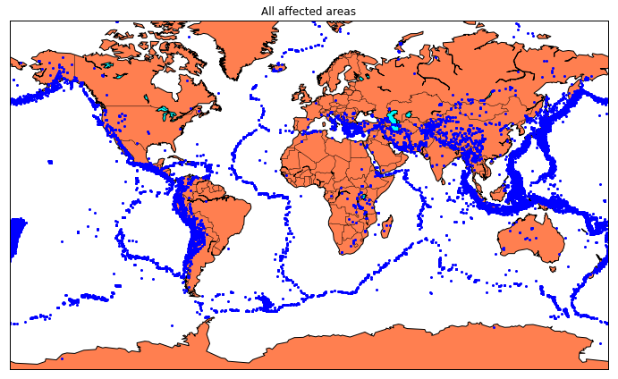

***SPLITTING THE DATA:***

1. *Firstly, split the data into Xs and ys which are input to the model and output of the model respectively.*
2. *Here, inputs are TImestamp, Latitude and Longitude and outputs are Magnitude and Depth.*
3. *Split the Xs and ys into train and test with validation.*
4. *Training dataset contains 80% and Test dataset contains 20%.*

***IN:***

*X = final_data[['Timestamp', 'Latitude', 'Longitude']]*

*y = final_data[['Magnitude', 'Depth']]*

*from sklearn.cross_validation import train_test_split*

*X_train, X_test, y_train, y_test = train_test_split(X, y, test_size=0.2, random_state=42)*

*print(X_train.shape, X_test.shape, y_train.shape, X_test.shape)*

*(18727, 3) (4682, 3) (18727, 2) (4682, 3)*

*from sklearn.ensemble import RandomForestRegressor*

*reg = RandomForestRegressor(random_state=42)*

*reg.fit(X_train, y_train)*

*reg.predict(X_test)*

***OUT:***

*array([[ 5.96, 50.97],*

*[ 5.88, 37.8 ],*

*[ 5.97, 37.6 ],*

*...,*

*[ 6.42, 19.9 ],*

*[ 5.73, 591.55],*

*[ 5.68, 33.61]])*

*EXAMPLE:*

*import pandas as pd*

*import random*

*# Generate synthetic earthquake data*

*n_samples = 100 # Number of earthquake data points*

*data = {*

*'Latitude': [random.uniform(-90, 90) for _ in range(n_samples)],*

*'Longitude': [random.uniform(-180, 180) for _ in range(n_samples)],*

*'Magnitude': [round(random.uniform(4.0, 9.0), 1) for _ in range(n_samples)]*

*}*

*# Create a Pandas DataFrame*

*earthquake_data = pd.DataFrame(data)*

*# Display the first few rows of the dataset*

*print(earthquake_data.head())*

*# You can save this dataset to a CSV file for future use*

*earthquake_data.to_csv('earthquake_sample_data.csv', index=False)*

1. ***Import Libraries:***

*First, we import the necessary Python libraries:*

*import pandas as pd*

*import random*

1. ***Define the Number of Data Points:***

*We specify the number of data points (earthquake events) that we want to generate. In this example, n_samples is set to 100, meaning we'll generate data for 100 earthquake events.*

1. ***Generate Synthetic Earthquake Data:***

*We create synthetic earthquake data using random values. Here's how each column is generated:*

* *'Latitude': We use random.uniform(-90, 90) to generate random latitude values between -90 and 90 degrees. This range covers the entire globe.*
* *'Longitude': We use random.uniform(-180, 180) to generate random longitude values between -180 and 180 degrees, covering the entire globe.*
* *'Magnitude': We use random.uniform(4.0, 9.0) to generate random magnitude values between 4.0 and 9.0. This range represents a typical range of earthquake magnitudes.The generated data is stored in the data dictionary.*

1. ***Create a DataFrame:***

*We use the Pandas library to create a DataFrame, earthquake_data, from the data dictionary. This DataFrame will hold our earthquake data.*

*earthquake_data = pd.DataFrame(data)*

1. ***Display the Dataset:***

*We print the first few rows of the dataset to see what it looks like.*

*print(earthquake_data.head())*

1. ***Save to a CSV File :***

*If you want to save the sample dataset to a CSV file for later use, you can use the following line of code:*

*earthquake_data.to_csv('earthquake_sample_data.csv', index=False)*

*This line saves the dataset to a file named 'earthquake_sample_data.csv' in the current directory. The index=False argument tells Pandas not to save the DataFrame index as a separate column in the CSV file.*

***Splitting it into training and testing sets :***

*from sklearn.model_selection import train_test_split*

*# Define your feature variables (X) and target variable (y)*

*X = earthquake_data[['Latitude', 'Longitude']] # Features*

*y = earthquake_data['Magnitude'] # Target variable*

*# Split the data into training and testing sets*

*X_train, X_test, y_train, y_test = train_test_split(X, y, test_size=0.2, random_state=42)*

1. *Import train_test_split Function:*

*You first import the train_test_split function from the sklearn.model_selection module. This function is part of the scikit-learn library and is used to split your dataset.*

1. *Define Feature and Target Variables:*

*You define your feature variables (X) and target variable (y):*

*X contains the feature data, which in this case includes 'Latitude' and 'Longitude' columns from your earthquake dataset. Depending on your model, you might include more features.*

*y contains the target variable, which is 'Magnitude' in this example.*

1. *Splitting the Data:*

*The train_test_split function is used to split your feature and target variables into training and testing sets.*

*X_train and y_train will contain the feature and target data for training your machine learning model.*

*X_test and y_test will contain the feature and target data for testing your model's performance.*

*test_size=0.2 specifies that 20% of the data will be used for testing, and the remaining 80% will be used for training. You can adjust this percentage to suit your needs.*

*random_state is set to 42, which is a random seed. Setting a random seed ensures that the split is reproducible; you can use any integer value for random_state.*